Passport-size photographs of all applicants associated with the proposed project are attached below.

1. Shaik Abdul Razak – B.Tech Computer Science & Engineering Student, Lead Applicant


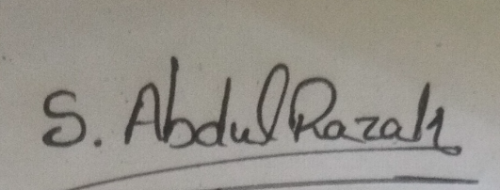

2. E. Tejaswini – PhD Scholar, Department of Foods and Nutrition, PJTSAU, Co-Applicant

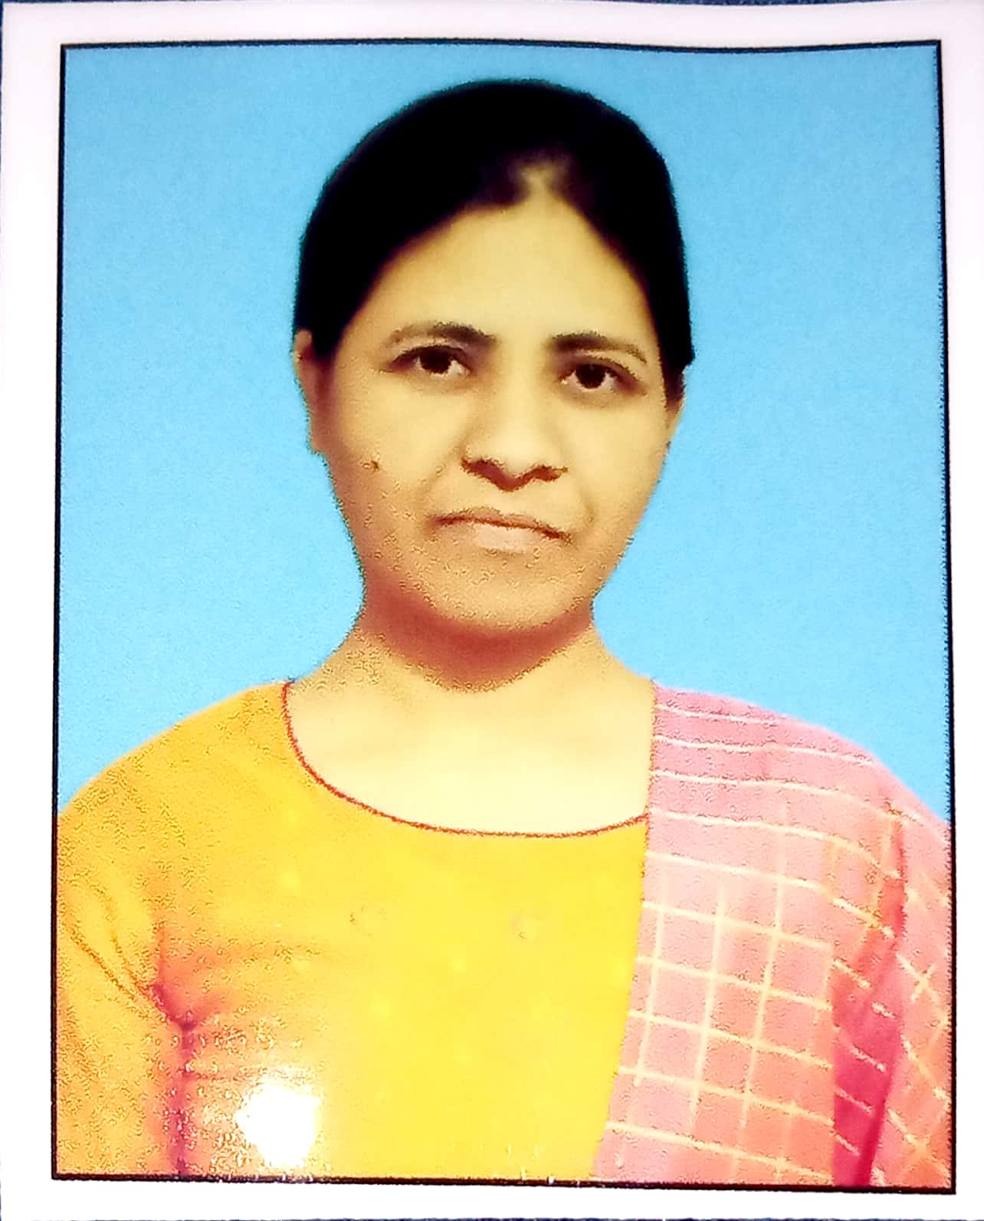

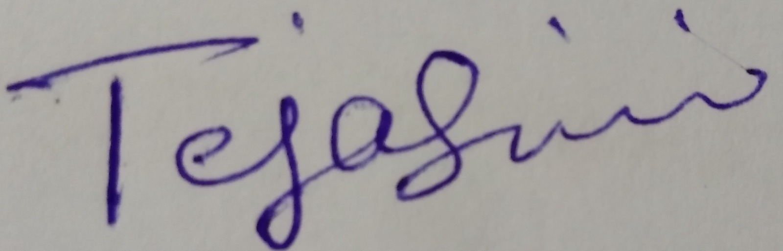

3. Dr. Ramagiri Praveen Kumar – Associate Professor, Chaitanya Deemed to be University, Mentor
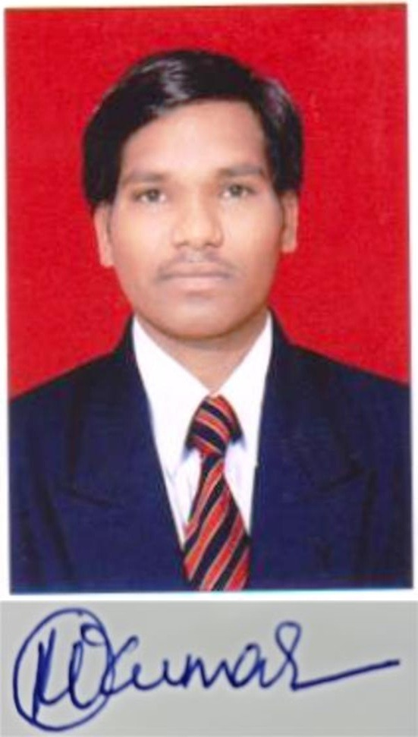
These individuals collectively form a multidisciplinary team combining expertise in technology, nutrition, and research to develop and scale the proposed millet-based functional food innovation.

